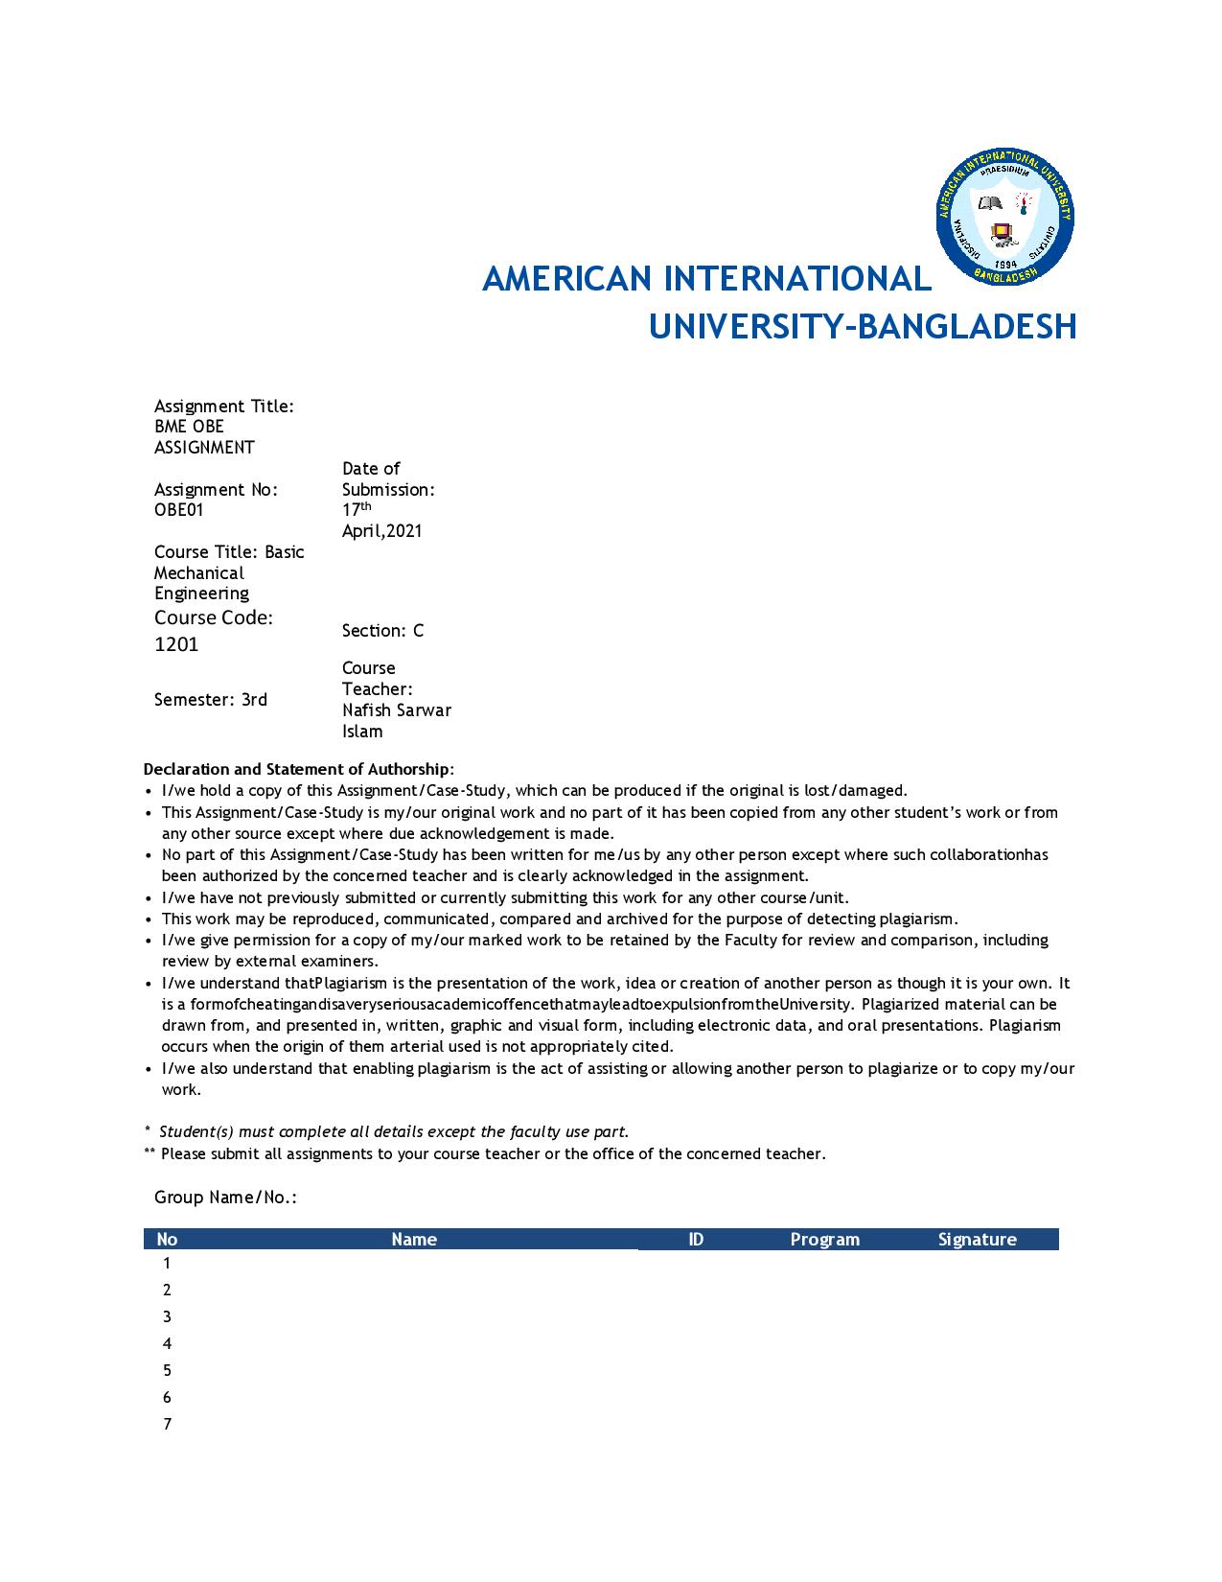

* Presented By :

Name : Morol,Shohan

ID : 20-44038-2

Subject : Basic Mechanical Engineering

Section : C

* Presented To :

Nafish Sarwar Islam

Assistant Professor, EEE

American International University- Bangladesh

BME OBE ASSIGNMENT

Performing the PESTEL and SWOT analysis in order to figure out the prospect of the solar driven vehicles instead of the internal combustion engines using hydrocarbon fuel (petrol, octane, diesel, CNG etc.) in context of Bangladesh

**Solar energy**, radiations from the sun capable of producing heat, causing chemical reactions, or generating electricity. The total amount of solar energy incident on Earth is vastly in excess of the world’s current and anticipated energy requirements. If suitably harnessed, this highly diffused source has the potential to satisfy all future energy needs. In the 21st century solar energy is expected to become increasingly attractive as a renewable energy source because of its inexhaustible supply and its nonpolluting character, in stark contrast to the finite fossil fuels coal , petroleum, and natural gas.

The Sun is an extremely powerful energy source, and sunlight is by far the largest source of energy received by earth, but its intensity at Earth’s surface is actually quite low. This is essentially because of the enormous radial spreading of radiation from the distant Sun. A relatively minor additional loss is due to Earth’s atmosphere and clouds, which absorb or scatter as much as 54 percent of the incoming sunlight. The sunlight that reaches the ground consists of nearly 50 percent visible light, 45 percent infrared radiation, and smaller amounts of ultraviolet and other forms of electromagnetic radiation.

The potential for solar energy is enormous, since about 200,000 times the world’s total daily electric-generating capacity is received by Earth every day in the form of solar energy. Unfortunately, though solar energy itself is free, the high cost of its collection, conversion, and storage still limits its exploitation in many places. Solar radiation can be converted either into thermal energy (heat) or into electrical energy, though the former is easier to accomplish.

A **solar car** is a solar vehicle used for land transport. Solar cars usually run-on only power from the sun, although some models will supplement that power using a battery, or use solar panels to recharge batteries or run auxiliary systems for a car that mainly uses battery power.

Solar cars combine technology typically used in the aerospace, bicycle, alternative energy and automotive industries. The design of a solar vehicle is severely limited by the amount of energy input into the car. Most solar cars have been built for the purpose of solar car races. Some prototypes have been designed for public use, and the lightyear one solar charged battery electric vehicle is expected to be available starting in 2021; currently, no cars primarily powered by the sun are available commercially.

Solar cars depend on a solar array that uses photovoltaic cells (PV cells) to convert sunlight into electricity. Unlike solar thermal energy which converts solar energy to heat, PV cells directly convert sunlight into electricity. When sunlight (photons) strike PV cells, they excite electrons and allow them to flow, creating an electric current. PV cells are made of semiconductor materials such as silicon and alloys of indium, gallium and nitrogen. Crystalline silicon is the most common material used and has an efficiency rate of 15-20%.

**Internal-combustion engine**, any of a group of devices in which the reactants of combustion (oxidizer and fuel) and the products of

combustion serve as the working fluids of the engine. Such an engine gains its energy from heat released during the combustion of the nonreacted working fluids, the oxidizer-fuel mixture. This process occurs within the engine and is part of the thermodynamic cycle of the device. Useful work generated by an internal-combustion (IC) engine results from the hot gaseous products of combustion acting on moving surfaces of the engine, such as the face of a piston, a turbine blade, or a nozzle. Internal-combustion engines are the most broadly applied and widely used power-generating devices currently in existence.

Examples include gasoline engines, diesel engines, gas-turbine engines, and rocket-propulsion systems. Internal-combustion engines are divided into two groups: continuous-combustion engines and intermittent-combustion engines. The continuous-combustion engine is characterized by a steady flow of fuel and oxidizer into the engine. A stable flame is maintained within the engine (e.g., jet engine). The intermittent-combustion engine is characterized by periodic ignition of air and fuel and is commonly referred to as a reciprocating engine. Discrete volumes of air and fuel are processed in a cyclic manner. Gasoline piston engines and diesel engines are examples of this second group.

PESTLE and SWOT are highly effective analysis tools to help you during the process of developing a strategic plan for your business. They can be used in isolation, however become significantly more effective when used in combination.

* **PESTLE**analysis considers the broad environmental context that affects the business and the changes that occur in this context.
* **SWOT**analysis then interprets these findings for the business to determine the strengths and weaknesses, and opportunities and threats.

If combined, PESTLE analysis is usually completed first to provide a context for the SWOT analysis.

**PESTLE Analysis:**

PESTLE analysis is, in effect, an audit or external scan of an organization’s environmental influences that helps guide the planning and strategic decision making. It is often referred to as providing a ‘big picture’ of the environment in which a business operates.

The assumption is that, if a business is able to audit its current environment and assess potential changes, it will be better placed than its competitors to respond to changes. Often, the analysis will determine likely issues/events that will impact the business – these are generally considered to be outside the control of the business.

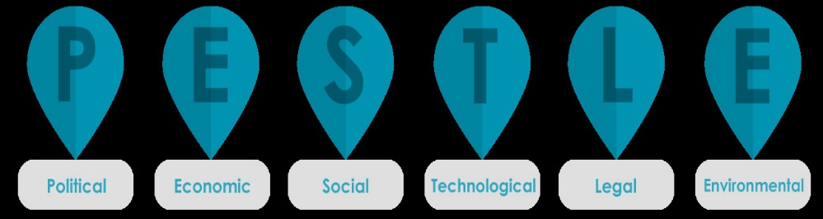The diagram below shows how all these different factors can influence the business or organization and how it operates.

**SWOT analysis**

As discussed earlier, SWOT analysis helps to interpret the findings of the PESTLE analysis to determine the business’s strengths and weaknesses, and opportunities and threats. It is important, as a part of the internal focus, to conduct the SWOT analysis prior to completing your business plan. It is a critical part of the risk management process.

It helps to understand SWOT analysis by classifying the strengths and weaknesses as an internal assessment of a business, so looking within a business at controllable factors. The opportunities and threats are therefore classified as an external assessment of the business, so looking at outside forces and influences that are beyond the businesses control.

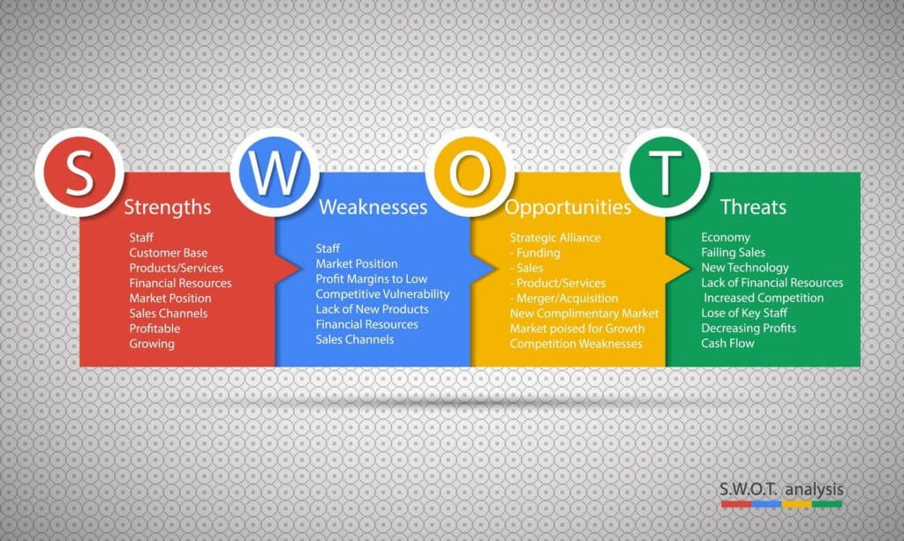

* **SWOT analysis of the solar driven vehicles instead of the internal combustion engines**

Strengths :

Solar energy is not so new in the world but when it comes to solar cars, that is a huge jump in terms of car development. We are no longer rely on any earth’s energy source anymore. We use green energy called **“solar power”**.

### Solar-powered vehicles have electric motors, and that is how they can convert solar into electrical energy with the help of photovoltaic cells. That means that they can operate without emitting any gases to the atmosphere. Environmental enthusiasts will always like the idea of solar-powered vehicles because it does not pollute the air. Sunlight is obtained for free, and it is a form of renewable energy compared to fossil gases, which has destroyed our atmosphere.

During production, solar power tends to consume resources and energy, but there is no extra energy or inputs required to operate once the production is done. They do not depend on petroleum, and oils significantly let us say only during lubrication of the wheels and some parts which need oiling. Most parts included in a solar-powered vehicle do not need a lot of maintenance than gas-powered engines. Therefore, once we shift to using solar powered vehicles, we can save many resources as such cars do not need fuel, gas, or maintenance resource.

With the recent developments in technology, solar panels are starting to drop their prices, making them readily available and cheaper. Another advantage of solar panels is that they are long-lasting, and one panel can operate for approximately 30 years. That is an exceedingly long time compared to ordinary vehicles that use fuel. You will no longer need to worry about fuel, diesel, and gas costs anymore.

The only use the solar-powered vehicles has today is only to race. They are designed in a way that they have a low wind resistance ability. The solar-powered vehicles are flat and have room only for the drivers. Things like wipers, rear motors, and headlights are never included when designing these cars. Their whole body is made with photovoltaic cells, enabling them to capture a lot of sunlight during the day.

Ever since the first solar-powered car was invented, investors have realized that solar energy is the way to go. All they need to do is develop a sophisticated technology that will use solar energy to operate. That means that everyday investors are trying to figure out how to improve solar vehicles’ performance and power so that we can drive freely using solar energy in the future. Technology is developing every day, and one day we will be able to drive solar-powered vehicles commercially.

Weakness :

Everything is too “expensive” when it comes to solar. We will need a lot of new things to have the actual solar car. Have you ever heard about inverters, batteries, wire, for a solar system? If yes, you might know that all of those will be very costly. And For, solar car, the same cost will be applied for it.

Solar-powered vehicles have a modest way of utilizing sunlight. Sunlight usually hits the earth at 1000 watts per square meter. When you convert that solar energy into electricity, it can produce around 200watts of electricity per square meter. That gives us an efficiency of 20%. That means that the amount of solar that hits your solar panel is approximately 2 kilowatts per square meter. Most of the motors available today are rated 200Kw, which is 50 times more than a regular solar panel. That means they can produce more kilowatts on their own.

Solar-powered vehicles need direct sunlight, and when sunlight is not available, there will be a slight problem. The solar panels used to make the vehicle need direct sunlight, and when it is raining, the efficiency of such vehicles will be below.

The number one reason why solar-powered vehicles can move is that they use energy. That energy needs to be stored in solar batteries, which might be hard when there is no sun for some days. The batteries are only charged during the day when there is sufficient sunlight. The energy can be used at night, and if you did not store sufficient energy, you might be in serious problems. The batteries themselves are not that cheap, considering they are only built for such cars. During the manufacturing process, there are harmful materials that are always used, causing harm to the atmosphere. Transporting those parts to and from the factory needs some lorries that will pollute the ozone layer.

**Opportunities :**

Solar companies can make deals with automotive companies so some cars would come stock with the solar panels. They could work with the municipalities to make solar panels for emergency vehicles as well. Due to this solar companies will be able to expand quickly.

Transparency Market Research has published a new report on the global solar powered car market for the forecast period of 2019–2027. According to the report, the global solar powered car market is projected to reach ~ US$ 3.5 Bn by 2027, expanding at a CAGR of ~20% during the forecast period.

Global Solar Powered Car Market: Overview

According to the report, the global solar powered car market is likely to be driven by the demand for zero-emission cars.

Self-driving cars are more efficient and cost-effective, and curb transportation emissions.

Key automakers such as Sono Motors GmbH, and Lightyear are projected to offer solar powered cars post 2020 and 2021, respectively, which, in turn, is expected to drive the solar powered car market.

Expansion of the Global Solar Powered Car Market

The depletion of fossil fuel has prompted global automakers to search for a viable option to maintain their pace of progress and development. Solar powered cars is presently one of the best possible alternate solutions.

The demand for zero-emission vehicles has compelled the automotive industry to design and develop new alternate technologies, such as solar powered vehicles that use solar radiant energy as a form of fuel to drive the vehicle.

Additionally, the light weight of the car makes it fast and highly efficient as compared to the conventional fossil fuel powered car.

**Threats :**

Other companies may make a far better Eco-friendly vehicle which could ruin SCC. Solar panels are expensive, people may buy electric cars.

Another threat is global climate change, because if an area that's usually sunny starts to urge tons of rain it's going to not charge the car enough. Also, with the rise in gas prices people will want to modify over to free car fuel

.Solar-driven vehicles are powered by electricity through the utilization of solar power , solar panels are attached to the surface of the vehicles’ PV cells covert the suns energy directly into electricity . when these panels enter landfills, valuable resources attend waste. and since solar panels contain toxic materials like lead which will leach out as they break down, landfilling also creates new environmental danger which may be a threat.

Solar-driven cars do not have any driver safety features and other equipment like wiper blades, headlights, and rearview mirrors. Aspects like suspension, brakes, and battery arrangement also got to be taken seriously. However, ICE has much safety of passengers. Transportation of solar systems has linkup to ozonosphere gas emissions. Moreover, as compared to combustion engines that use hydrocarbon fuel, solar power pollutes the atmosphere less.

In future the solar driving cars will have huge competition in automobile market and it may increase the cost of input.

* **PASTEL analysis of the solar driven vehicles instead of the internal combustion engines**

The PESTEL analysis will look at the benefits

and drawbacks of Solar Electric Vehicles with concerning political,

economic, social, technological, environmental, and Legal factors.

**Political Factors :**

* The government of Bangladesh sketched a commercial coverage

to attract in surroundings pleasant automobile manufacturing traces or even SEV producers

to the country [1].

* The ministry of road transport and bridges is

making ready a coverage for vehicle mobile enterprise that may contain not less than 15% of registered motors to be powered through eco-friendly energy in 2030. This coverage will offer significance at the manufacture and meeting of ecofriendly motors [1].

* Policymakers strive their best to attract in automobile producers like Toyota and Volkswagen through imparting loose land and extra centers to fabricate EVs, inclusive of sun-pushed ones [1], [2].

* In 2016, Bangladesh signed the Paris Climate Agreement on the United Nations and entreated different nations, mainly developed ones, to collaborate with each other to fight worldwide weather change. This

indicates that the country is prepared to deliver help to any organization looking to increase green technology like SEVs [3]

**Economic Factors ;**

* We all want clean air for survival. But ground-level ozone and

different pollution from automobiles, strength vegetation, commercial boilers, refineries, and chemical vegetation can kill. The harm extends to crops, timber, and different vegetation, and the toll on human lifestyles is significant. Pollution is so horrific in a few elements of the arena that human beings are advised to live indoors. The Environmental Defense Fund states that pollutants are accountable for the deaths of 6.four million human beings per year.11

In contrast, solar energy helps a planet this is easy and green. By eliminating dangerous poisonous emissions from fossil fuels, the sun lets us breathe less difficult and offer wholesome air for destiny generations

* Fuel charge can be a massive difficulty in the industry, and it mainly has an impact on low-profit groups in Bangladesh. A hike in gasoline charge will cause an extra call green motors. In phrases of performance and running expenses, selecting a SEV can be a feasible answer for purchasers as those motors derive their strength at once from solar. This presents a moneymaking possibility for SEV producers to earn revenue.

* a large majority of the motors in Bangladesh have

been imported from abroad. for instance, the country imported $470,239,000 worth of motors in 2019 alone [4]. NBR collects 50 billion (BDT) as revenue from vehicle imports. the size of the car industry of Bangladesh is around 1400 crore ($164 million). The emergence of ride-sharing systems inclusive of Uber, Pathao et al. are also contributing to the growing call for motors[5]. its the right time to increase enterprise to deliver motors which are green and surroundings pleasant like SEVs to reduce the reliance on imports and make stronger the nearby enterprise.

* The car enterprise can reason a variety of benefits for an economy, including that a plant needs among 5000 to 15000 elements to form a vehicle. By setting up production vegetation for the meeting of SEVs, it is able to easily create employment for lots of people that may assist to boost Bangladesh’s economy.

* SEVs are a completely new idea for Bangladesh. So, there's a hazard that the amount of income of these motors may not grow properly. the purpose at the back of that is frequently that folks may not feel comfortable with this new era as they're now no longer skilled with its use. This uncertainty may also create troubles for the solar vehicle industry. The solar is a renewable resource. Unlike fossil fuels, daylight is never going away. We can anticipate it each day.

Coal and natural fuel lines aren't free, and they're costly and dirty. Their price is risky too and has increased systematically during the last decade. But there is no fuel cost for daylight. With Sunrun’s residential sun, we'll know your annual strength costs for at the least the following decades. The sun is a renewable resource. Unlike fossil fuels, sunlight is never going away. We can count on it every day.

Coal and natural gas are not free, and they are expensive and dirty. Their price is volatile too and has increased systematically over the past decade. But there is no fuel cost for sunlight. With Sunrun’s residential solar, you will know your annual energy expenses for at least the next two decades.

**Social Factors:**

* Solar electric vehicles are connected, fun, and practical. they will reduce emissions and even economize because electricity is cheaper to use than the petrol and fuel utilized in conventional IC engine cars. So SEVs are eco-social and eco-friendly also.

* The unemployment problem is often reduced by producing SEVs in Bangladesh. The unemployed people of the society are often employed by the govt as labor to form SEV production possible within the country.

* Younger generations of Bangladesh’s population are encouraged to be more environmentally conscious thanks to greater awareness of global climate change. These people are much more likely to get electric vehicles like SEVs as ownership of those vehicles is usually used as a signifier of getting an eco-friendly lifestyle [6].

* one among the obstacles to EV adoption, including solar-powered ones, is range anxiety. this is often defined because the stress that stems from the vehicles’ perceived lack of range and therefore the user’s belief that they could become stranded as a result. Range anxiety arises albeit the car is capable of travelling far longer distances than the driver’s average commute [7]. This negative perception may prevent people from buying SEVs.

* Much of the cobalt used for the EV batteries come from the Democratic Republic of Congo. thanks to widespread poverty and low regulations, child labor is usually utilized in cobalt mining operations which is unethical and antisocial [8].

**Technological Factors:**

* Solar photovoltaic cells are only 20% efficient and need an outsized area so as to get sufficient power. This size requirement is impractical for smaller commercial vehicles in high-density urban centers like Dhaka. However, energy sources also can be utilized in tandem with solar energy in SEVs [11].

* Bangladesh’s population heavily relies on individualized paratransit vehicles like rickshaws and three-wheelers for short-distance commutes and last-mile connectivity. The shorter ranges are optimal for battery-powered light vehicles. at the present, it's estimated that there are almost 1 million battery-powered three wheelers operating in Bangladesh [12]. These vehicles are often easily converted to run on solar energy with minimal modifications, which ensures an outsized potential base for early adoption of solar technology.

* The internals of SEVs have fewer moving parts than ICEVs, making them less susceptible to breaking down. This also reduces vehicle maintenance and maintenance costs for the typical consumer which can favor its adoption [13].

* Bangladesh’s National Grid is susceptible to power fluctuations and cargo shedding. This represents a plus for SEVs over their conventional plug-in counterparts as they are doing not got to believe the Grid for power [10].

* SEVs generally have reduced range compared ICEVs which, combined with the shortage of charging stations [14], makes them unsuitable for long-distance travelling beyond city limits.

**Environmental Factors\***

* Bangladesh enjoys above-average radiation thanks to its location. on the average, the daily radiation usually varies from 4 to six .5 kWh/m2 [16]. The high level of insolation makes the country a major target for the use of SEVs.

* With regards to air quality, Bangladesh is one among the worst ranked countries within the world. one among the explanations for this is often the continued usage of old and inefficient ICEVs which lack the catalytic converters required to scale back harmful emissions [17]. In contrast, SEVs produce zero exhaust gases and thus, can help improve air quality if they replace existing ICEVs. These cars also can help with sound pollution, especially in cities where speeds are generally low, as their electric engines are far quieter than combustion ones which reduces noise during operation.

* the assembly of the batteries required by EVs for energy storage produces a negative impact on the environment. Lithium, cobalt, and cadmium etc. are often utilized in the making of the battery. The mining of those minerals alone releases more CO2 emissions than the assembly of ICEVs. The toxicity of the compounds in these batteries also complicates disposal procedures [18]. For SEVs, the assembly of PV cells for the panels also can impact the environment. Cadmium telluride, which is employed to supply these cells, was believed to be a more dangerous pollutant than fossil fuels. Hence, the manufacture of SEVs poses a risk to the environment.

* Possible increased particulate emissions from tires. this is often sometimes caused by the very fact that the majority SEVs have an important battery, which suggests the car's tires are subjected to more wear. The restraint, however, are often used less frequently than in non-electric cars, if regenerative braking is out there and should thus sometimes produce less particulate pollution than brakes in non-electric cars. Also, some electric cars may have a mixture of drum brakes and disc brakes, and drum brakes are known to cause less particulate emissions than disc brakes.

**Legal Factors:**

* Battery-powered EVs face steep tax charges (89.7%) if imported as a totally built unit (CBU). However, this charge goes right down to on 37% if the vehicle is imported as completely knocked down unit (CDU)[19]. this suggests that it might be cheaper to import the parts and assemble the SEV locally but this course of action carries the prerequisite of building sophisticated assembly plants for high-end vehicles.

* The Bangladesh Road Transport Authority has also faced bureaucratic hurdles with regards to taxing EVs because the tax brackets are supported vehicle IC engine capacity measured in cubic centimeters (CC) whereas the capacity for electric motors are measured in kilowatts (kW) [20]. the problem in registering these vehicles may reduce the likelihood of consumer adoption of SEVs.

* The Sustainable & Renewable Energy Development Authority Act 2012 has authorized a governmental body to oversee development of renewable energy technologies. one among the foremost goals of this organization is to encourage the usage and development of renewable energy technology while limiting non-renewable energy [21]. this might enable solar-powered and other environmentally friendly vehicles to realize greater market share over vehicles with combustion engines.

* Statutory Regulatory Order No. 155-Law reduces import tax, VAT and other duties on solar array equipment which may make it cheaper for local manufacturers to supply SEVs [22]. These savings can then be passed on to consumers, which can prompt them to choose these vehicles rather than ICEVs.

References

[1] Md. N. H. Suman, F. A. Chyon, and Md. S. Ahmmed, “Business strategy in Bangladesh—Electric vehicle SWOT-AHP analysis: Case study,” International Journal of Engineering Business Management, vol. 12, p. 1847979020941487, Jan. 2020, doi: 10.1177/1847979020941487.

[2] “Car Imports by Country,” World’s Top Exports, May 01, 2020. https://www.worldstopexports.com/cars-imports-by-country/ (accessed Apr. 16, 2021).

[3] “Bangladesh Automotive Industry: A Roadmap to the Future,” LightCastle Partners, Jul. 09, 2020. https://www.lightcastlebd.com/insights/2020/07/bangladesh-automotive-industry-a-roadmap-to-the-future (accessed Apr. 16, 2021).

[4] Z. Rezvani, J. Jansson, and J. Bodin, “Advances in consumer electric vehicle adoption research: A review and research agenda,” Transportation Research Part D: Transport and Environment, vol. 34, pp. 122–136, Jan. 2015, doi: 10.1016/j.trd.2014.10.010.

[5] S. Z. Rajper and J. Albrecht, “Prospects of Electric Vehicles in the Developing Countries: A Literature Review,” p. 19, 2020.

[6] B. Faber and B. Krause, “Artisanal Mining, Livelihoods, and Child Labor in the Cobalt Supply Chain of the Democratic Republic of Congo,” p. 61.

[7] J. Connors, “On the Subject of Solar Vehicles and the Benefits of the Technology,” in 2007 International Conference on Clean Electrical Power, Capri, Italy, May 2007, pp. 700–705, doi: 10.1109/ICCEP.2007.384287.

[8] Md. R. Ahmed and A. K. Karmaker, “Challenges for Electric Vehicle Adoption in Bangladesh,” in 2019 International Conference on Electrical, Computer and Communication Engineering (ECCE), Cox’sBazar, Bangladesh, Feb. 2019, pp. 1–6, doi: 10.1109/ECACE.2019.8679288.

[9] “Viability of solar powered vehicles,” JAKSON BLOG, Dec. 06, 2019. https://www.jakson.com/blog/viability-of-solar-powered-vehicles/ (accessed Apr. 15, 2021).

[10] “Electric Vehicles: Guideline talks start after 2-year pause,” The Daily Star, Jan. 17, 2021. https://www.thedailystar.net/backpage/news/electric-vehicles-guideline-talks-start-after-2-year-pause-2028977 (accessed Apr. 15, 2021).

[11] “EV Maintenance,” EV Resource. https://www.ev-resource.com/ev-maintenance.html (accessed Apr. 16, 2021).

[12] “Solar Charging Station | National Database of Renewable Energy, SREDA.” http://www.renewableenergy.gov.bd/index.php?id=1&i=8 (accessed Apr. 17, 2021).

[13] “EDGAR - The Emissions Database for Global Atmospheric Research.” https://edgar.jrc.ec.europa.eu/country_profile/BGD (accessed Apr. 16, 2021).

[14] S. Mistry, “Prospect of solar energy use in Bangladesh,” Jan. 2009, Accessed: Apr. 17, 2021. [Online]. Available: http://lib.buet.ac.bd:8080/xmlui/handle/123456789/870.

[15] “Bangladesh Air Quality Index (AQI) and Air Pollution information | AirVisual.” https://www.iqair.com/us/bangladesh (accessed Apr. 16, 2021).